The current system used in Supply Chain Engineering to manage manufacturing and field quality issues is made up of several systems. The diagram below shows the systems used and information flow between the many systems.

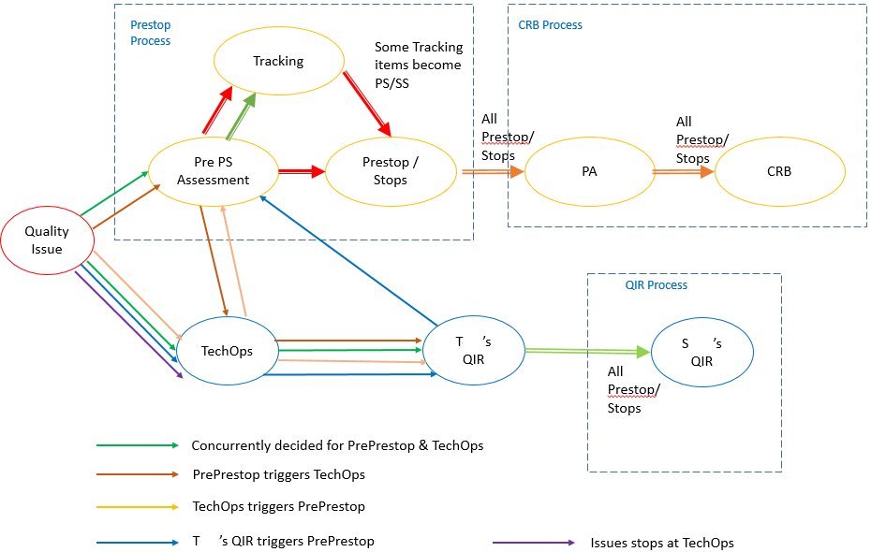

Fig 1. Quality Issue Information Flow

The key processes that make up a good issue management process is to manage the issue first, the look at lessons learned and develop preventative actions. You need to gather key data, bound the issue (when did it occur, where is it used, what’s the impact on production, how can the issue be contained, what manufacturing actions need to be taken, what field actions need to be taken), Root cause and corrective action need to be determined, what lessons can be learned from the issue and what can be done to prevent this issue from happening again.

In IBM there are 3 systems used to manage this process. The Stop Ship database is a Lotus Notes application created in the early 2000’s that has been refreshed multiple times. Data is extracted from the workflow and transformed into DB2 tables for analysis. To aid in the management of the issue, IBM conducts an issue review at the 2nd line and director levels called Tech Ops/Hot Topics. The information used in these reviews are typically PowerPoint presentations stored in team rooms. Issues deemed critical will move to the Supply Chain Engineering Vice President’s Quality Issue Review Meeting. Information here is extracted out of the Tech OP presentations or the Stop Ship database and inputted into a newly developed IBM Forms application called QIR Form. Information is extracted out of the forms using JavaScript and loaded into DB2 tables for analysis. Issues that have been contained then are tracked through a Control Review Board process that looks at preventative actions being developed to prevent the issues from returning. These are managed in a spate section of the Stop Ship database. Failure analysis that requires suppliers to execute an 8D process are provided in emails and pdf files that need to be extracted and added to Lotus Notes databases or stored in team rooms.

The proposal is to develop a single system that would allow us to manage all of these processes. Since these processes share the same data, it makes sense that the information be centralized so the different processes can utilize and interact with the same data. The solution would require the use of MongoDB and My SQL to manage the shared data. Express would be used to model the data structure. Angualr.js and Node.js would be used to develop this web based CRUD (Create, Read, Update, and Delete) application.

Duration of the project would be 4 months.